EXPERIMENT 9 HOSPITAL INFORMATION SYSTEM

Step1: Creating an application as ‘Hospital Information System’

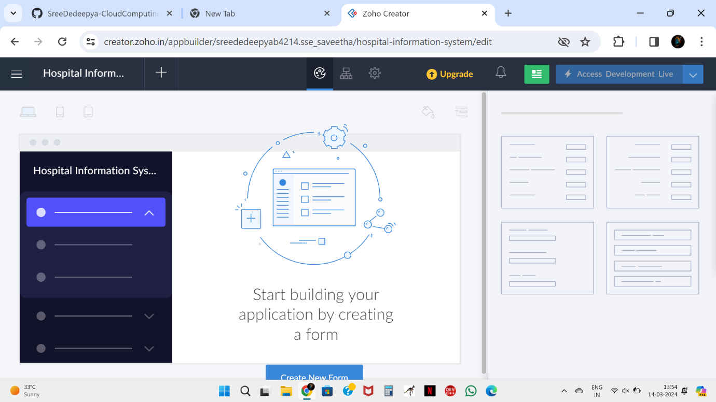

Step 2: Creating the form called as ‘Hospital Details’ and patient Details

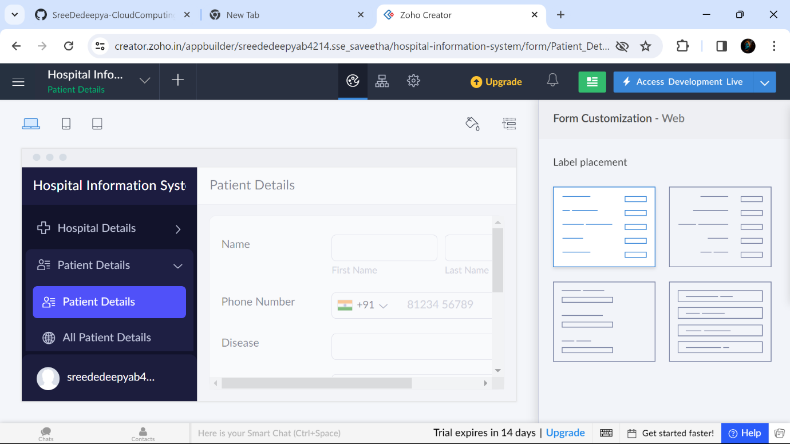

Step 3: Creating the form called as Doctor Details’

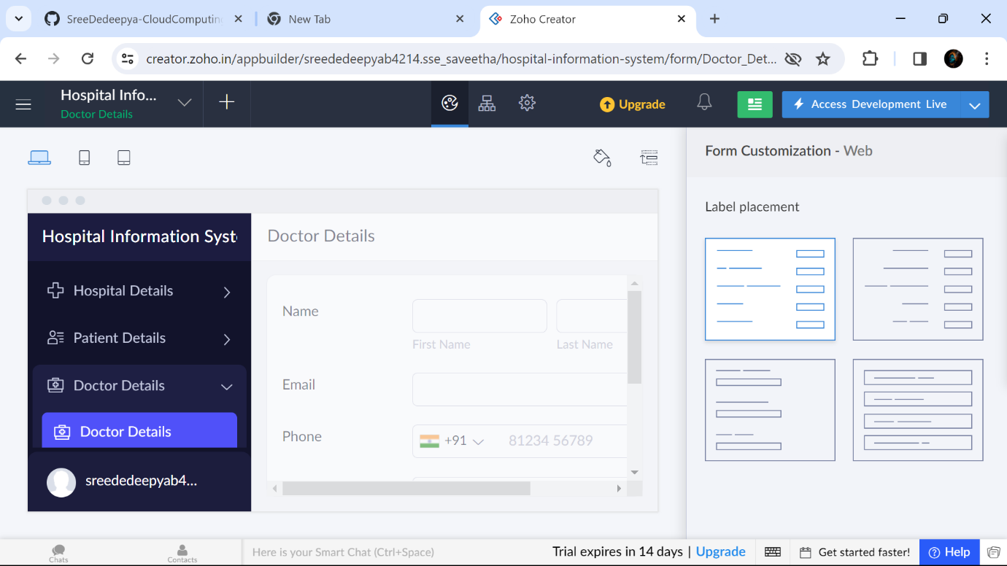

Step 4:Displaying the details in the ‘Hospital Details’

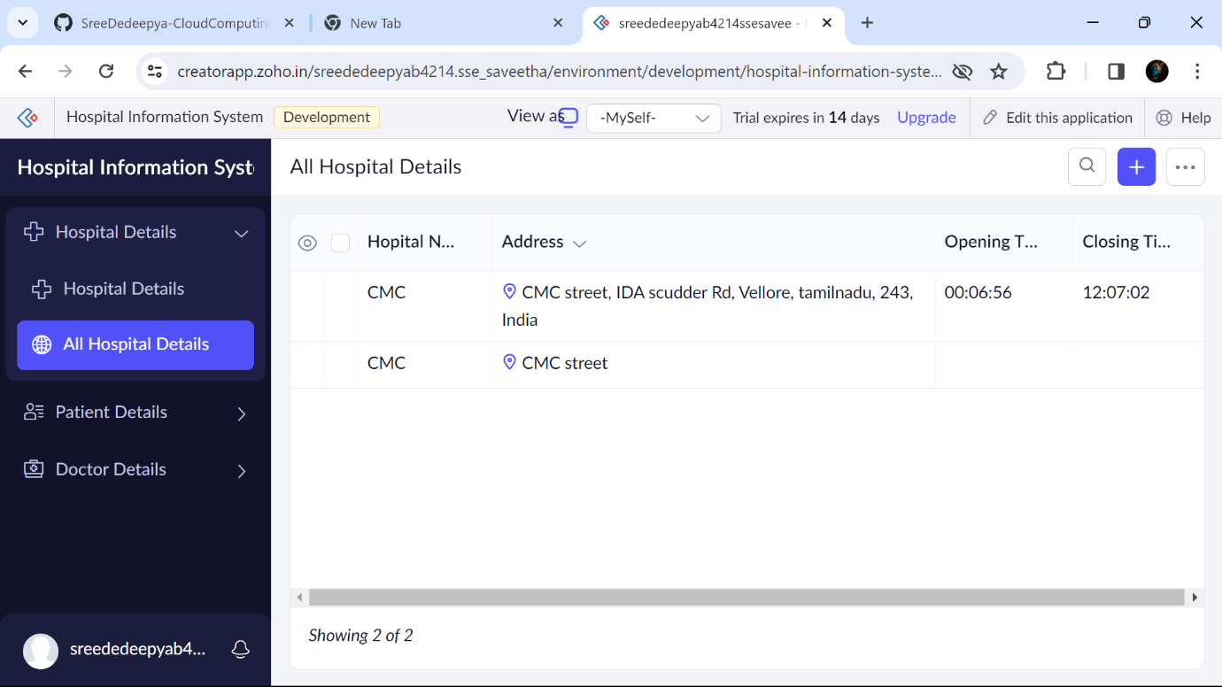

Step 6 :Displaying the details in the ‘Patient Details’

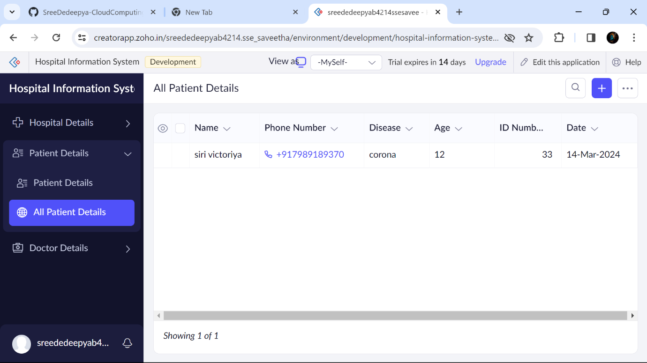

Step 4:Displaying the details in the ‘Doctor Details’

